#NHSPAY15

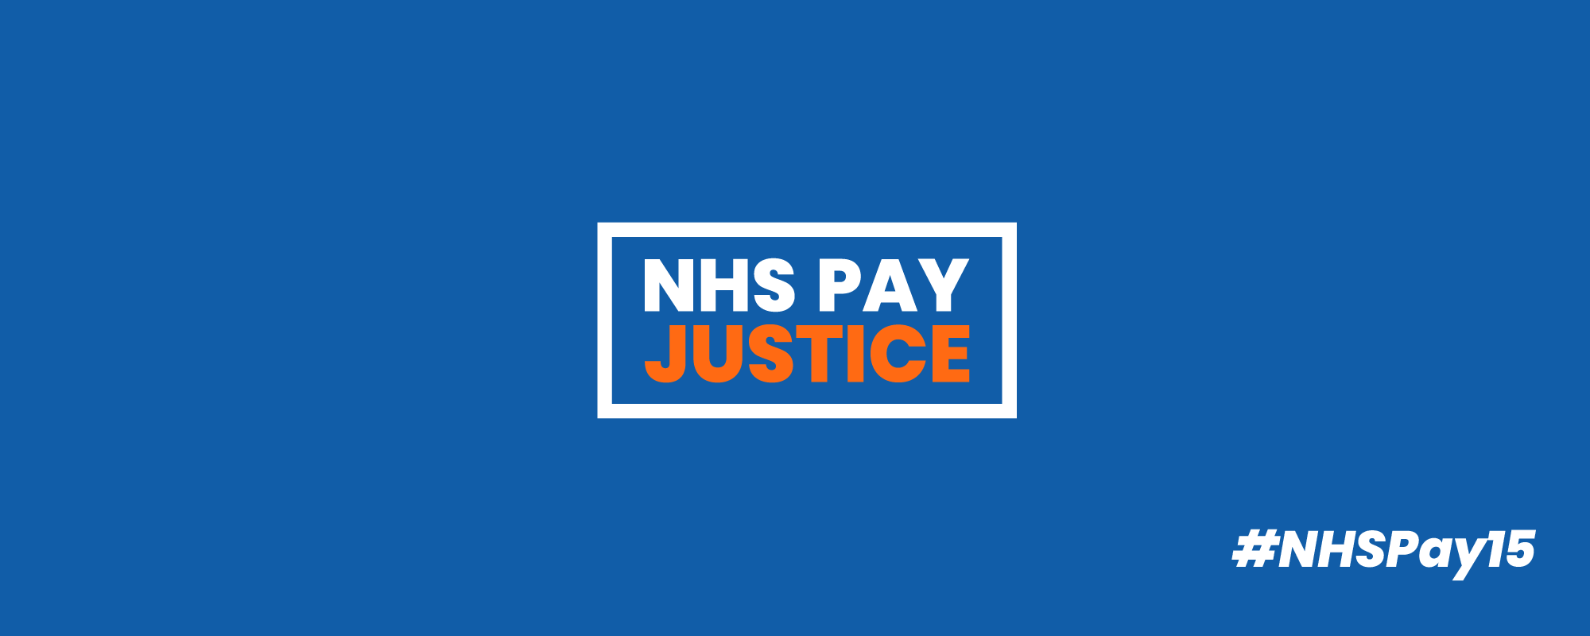

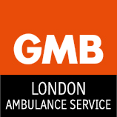

8th October 2020

GMB BULLETIN: NHS PAY 2021

GMB, the Union for NHS Staff, is committed to campaigning for Pay Justice for all NHS Staff. We have been proud to offer support to the countrywide protests and demonstrations being led by NHS workers of all professions and we will continue to do so.

Health Unions Coordinated Campaign

GMB continues to work with other health trade unions to lobby government for an ‘early and significant pay increase’ in the form of a fully funded one year deal. We have requested that government meet unions to negotate this year’s pay increase. However, it is most probable that we will be taken via the NHS Pay Review Body (PRB). Should this happen, health unions will make submissions to the PRB collectively on issues we are united on.

GMB’s Pay Claim

GMB has written to Government giving details of what pay justice for NHS staff means to our members and to ask that no restrictions are placed on the PRB if that is how pay will be determined this year. GMB was the only union to say no to the last three year pay award and we have been proven right to do so on many occasions since it was imposed. GMB will be making an individual union submission into the PRB and we will be consulting you further on this in the coming weeks.

GMB’s National NHS & Ambulance Committees have agreed after consultation with members that the GMB pay claim will include:
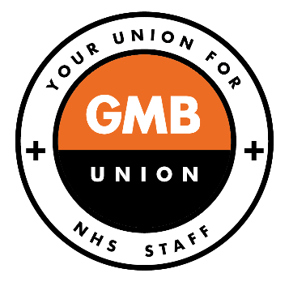
- 15% increase, or £2 per hour, whichever is the greatest.
- Unsocial hours enhancements to be payable when on sick leave for all staff.
- A one year deal.
- A commitment that NHS Pay will never fall below a Real Living Wage again.

Have Your Say on Your Pay

It is essential that we have your correct contact details and workplace information so that we can keep you updated as this campaign develops. Please update your details by contacting your local GMB Representative or online at: https://www.gmb.org.uk/mygmb-login

Get Involved!

This is your pay campaign and we need you to get involved so we can secure pay justice for all NHS staff.

- Speak to work colleagues about this campaign.

- Pass on this poster / flyer to colleagues.

- Ask non-members to join GMB today on our dedicated NHS joining page:

https://www.gmb.org.uk/nhs-join

- Organise a virtual workplace meeting. Contact your local GMB Representative if you need support to do this.

https://www.gmb.org.uk/gmb-regions

- Become a GMB Rep in your Workplace by emailing NHS@gmb.org.uk

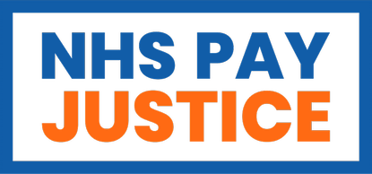
- Join and Like our Facebook Page

https://www.facebook.com/GMBUnionNHS/

- Follow our Twitter Account

https://twitter.com/GMBNHS

- Not a GMB Member? Join today using the link below or scan:

https://www.gmb.org.uk/nhs-join

GMB LAS UNION
IF YOU ARE NOT A MEMBER OF GMB LAS UNION AND WOULD LIKE TO JOIN TODAY PLEASE VISIT WWW.GMB.ORG/JOIN OR USE THE SCAN BELOW GMB IS THE LARGEST UNION FOR AMBULANCE WORKERS NATIONALLY
