Protect the Protectors: New GMB charter to prevent attacks

13 Nov 2019

Article By GMB Union
@GMB_union
Press Office

Press Office
07958 156846
press.office@gmb.org.uk
One year on from the Protect the Protectors bill becoming law, GMB has launched a charter to step up action against those who attack ambulance workers.
The Charter asks employers to take a Zero Tolerance approach to those who assault emergency workers, and take immediate steps that will help minimise the chance of Physical and sexual assault on emergency workers.
The Assaults on Emergency Workers (Offences) Act 2018 introduced a new offence of common assault against an emergency worker and requires courts to treat attacks on emergency workers as an aggravating factor for sentencing purposes.
Initially sexual assaults were not covered by the Bill, until a GMB investigation revealed reported sexual assaults on ambulance workers and other sexually abusive incidents increased by 211 per cent between 2012/13 and 2016/17. The research also revealed that on average there are more than eight recorded attacks (8.2) on ambulance workers every single day.
GMB’s is calling on employers to take steps which include:
· Fair & equal treatment for all staff
· Effective recording of action taken in response to all assaults.
· Work in partnership to share data & upgrade flagging systems.
· Update all policies to better protect staff from assaults.
· Mandatory training for all managers and Staff.
· Independent reporting of time off as a result of assaults
· Support staff in bringing prosecutions
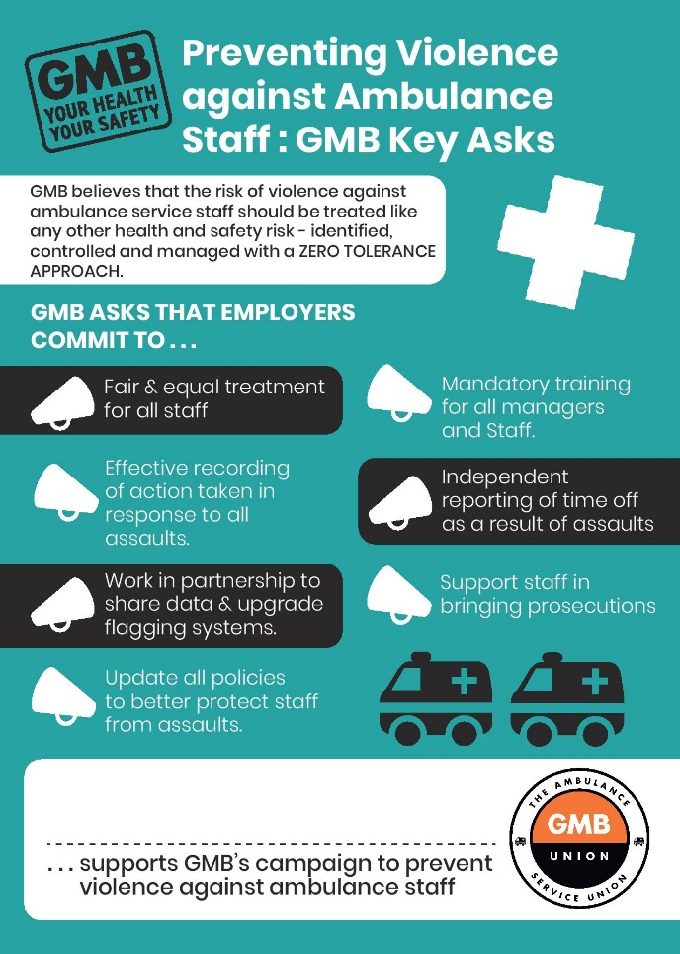
Rachel Harrison, GMB Organiser, said:
“We’re calling on employers to do their bit to protect the protectors.
“Whilst huge steps were taken last year to protect Ambulance staff, we think that more has to be done to ensure their safety when serving the public. It’s not right that any person faces violence and sexual assault in the workplace, let alone emergency workers.
"By implementing the charter, Employers can help minimise the threats to our brave Emergency workers and reassure them that they are taking the necessary steps to minimise the risks of violent, common and sexual assault at the workplace”

